**Supplementary Material: Novel nonlinear optical trapping effect with reverse saturable absorption**

Zheng Zhu,a,b,c,# Yuquan Zhang,a,#,* Shuoshuo Zhang,a Aurèle J. L. Adam,c Changjun Min,a H. Paul Urbach,c and Xiaocong Yuan,a,b,*

aShenzhen University, Nanophotonics Research Center, Institute of Microscale Optoelectronics & State Key Laboratory of Radio Frequency Heterogeneous Integration, Shenzhen 518060, China

bZhejiang Lab, Research Center for Humanoid Sensing & Research Institute of Intelligent Sensing, Hangzhou 311100, China

cDelft University of Technology, Optics Research Group, Lorentzweg 1, Delft, 2628 CJ, The Netherlands

#These authors contributed equally.

*Corresponding authors: [yqzhang@szu.edu.cn](mailto:yqzhang@szu.edu.cn); [xcyuan@szu.edu.cn](mailto:xcyuan@szu.edu.cn).

**Supplementary Note I: Experimental configuration**

The schematic diagram of the experimental setup is based on our simulation parameters, as shown in Fig. S1. We used an x-polarized pulsed laser with a pulse duration of 100 fs and 80 MHz repetitive frequency as a light source. The laser beam from a Ti: sapphire laser is firstly linearly polarized by a polarizer, and its polarization direction is then regulated by rotating a half-wave (λ/2) plate. After passing through the second polarizer, the laser power can be changed by rotating the λ/2 plate with the controller. The circularly-polarized beam is obtained by a quarter-wave (λ/4) plate. The polarized CVB is produced by the set of vortex retarders with a half-wave plate used to control the orientation of the polarization pattern of high-order CVBs. The CVB is focused by the objective lens after passing through a dichroic mirror into a glass microtube cell with gold nanoparticles in water. Then it is focused by an objective lens with NA = 0.65 inside a glass micro-tube, and the sample solution with gold nanoparticles of 60 nm diameter is filled in the micro-tube. The light emitted by the illuminator indicated in green is used to illuminate the sample solution. The illumination and the trapping beam incident orthogonally into the sample tube; thus, only the scattered illuminating beam can be collected by the objective. This design works like the dark-field illumination and helps to improve the motion presentation of the gold nanoparticles on the CCD.



**Fig. S1. The schematic diagram of experimental setup.** A x-polarized pulse laser propagates through a quarter wave plate to generate circular polarization beam. The laser beam is focused by an objective with 0.65 NA. The sample solution consisting of 60 nm gold nanoparticles is filled in the glass micro-tube. An additional green beam is used to illuminate the sample. The experimental manipulation process is observed through the objective and imaged on the CCD.

**Supplementary Note Ⅱ: Tightly focused optical fields**

The electromagnetic field plays an essential role in determining the direction and magnitude of the optical force. To excite the nonlinear effect of the particle, it is highly desirable to focus the incident optical field with a high NA objective lens. In this work, to demonstrate a novel trapping state induced by the RSA effect, we consider the incident field as a paraxial, left-handed circularly-polarized, femtosecond laser pulse. At the excitation wavelength *λ* = 840 nm, the wave number in the host medium (water) is *k* (*k* = 2π*nh* / *λ*), *nh*being the refractive index of host medium. The maximum focal angle *θ*max is determined by the NA of the lens and the host medium as *θ*max = arcsin (NA / *nh*). We use cylindrical coordinates in the focal region, given by *ρ*, *ϕ*, and *z*, with ρ the polar radius, *ϕ* the azimuth angle, and *z* the coordinate along the optical axis. The focal plane is assumed located at *z* = 0. Then, the electromagnetic field in the focal region can be derived as:36

 (S1)

 (S2)

with

 (S3)

 (S4)

 (S5)

where *Zμε* denotes the wave impedance, *Jm* is the *m*-th order Bessel function of the first kind, and *l*(θ) represents the pupil function of the incident field, given as:

 (S6)

where *fw* is defined as the filling factor (i.e., the radius ratio of the beam waist to the entrance pupil), and $E_{00}$ is the amplitude factor associated with the optical power. In fact, the electromagnetic field calculated based on Eqs. (S1) – (S6) only represents the spatial distribution of the focused field. For a femtosecond laser pulse, the peak power is estimated from the pulse duration *τ* and repetition frequency *ν*

 (S7)

where *γ* is the factor depending on the temporal shape of pulse and *v* is the repetitive frequency of the pulse laser. For the Gaussian shape pulse and soliton pulse, the factor is 0.94 and 0.88, respectively.43 In this paper, we assign the incident pulse in our analytical model a rectangular temporal envelope and *γ* = 1. In this scenario, the strength of the pulse will remain steady over the pulse duration. The peak intensity of the focused field can be expressed as *I*peak = 2*P*ave / π*R*2, where *R* is the radius of the focused spot of light.44 The square of modulus of the peak electric field |Epeak|2 = 2𝐼peak/(*ε*0*cnh*),45 *ε*0 is the permittivity of vacuum and *c* is speed of light in vacuum.

The peak value of the electric field and the magnetic field of the focused circularly-polarized femtosecond laser pulse are displayed in Fig. S2. Here, all numerical calculations in this paper are performed under the conditions that *f* = 4.5 mm, NA = 0.65, *fw*= 1, *nh* = 1.33, *τ* = 100 fs, and *ν* = 80 MHz, according to the experiments.



**Fig. S2. Focal field distributions of a circularly-polarized femtosecond laser pulse with an averaged power *P*ave = 1.54 W (i.e., the maximal power used in experiment).** (a‒d) The square of the modulus of the peak electric field in the focal plane (a) The square of the modulus of the total electric field (b-d) The x, y and z component of the electric field. (e‒h) The magnetic field in the focal plane.

**Supplementary Note Ⅲ: Dipole approximation theory of optical force**

When a small particle with a radius (*r*) is in the Rayleigh regime (*r* << λ), it can be modeled as an electric dipole in response to the incident optical field. According to the Lorentz law, the instantaneous force exerted on the particle is determined by46

 (S8)

where the real electric field $E=Re\left(\left[E_{0}\left(r\right)exp\left(-iω_{0}t\right)\right]\right)$, the real magnetic field $H=Re\left(\left[H_{0}\left(r\right)exp\left(-iω_{0}t\right)\right]\right),$ and the electric dipole $P=Re\left(\left[p_{0}\left(r\right)exp\left(-iω_{0}t\right)\right]\right)$ with $p_{0}\left(r\right)=αE_{0}\left(r\right)$. Here, *α* represents the polarizability of the particle (see Eq. (4) in the main-text). The time-averaged optical force on the particle can be derived by an integral of the instantaneous force over one pulse cycle *T* = 1 / *ν*:

 (S9)

The final expression of the time-averaged optical force on the basis of the dipole approximation theory is given as:

 (S10)

In Eq. (S10), the first term is the gradient force, and the second term is the scattering force. The extinction cross section *σ* = *k*Im(α) / *ε*. *ε* is the permittivity of the surrounding medium. In the focal plane, the scattering force mainly drives the particle to form an orbital circumgyration, as shown in Fig. S3. Consequently, the formation of the radial potential well is mainly contributed by the gradient force.

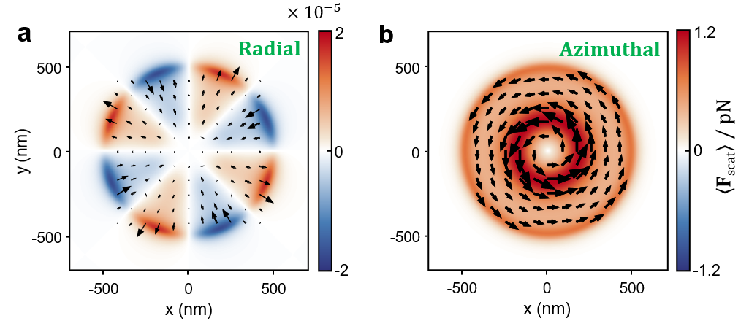

**Fig. S3. Scattering force acting on the gold nanoparticle in the focal plane when the averaged incident power *P*ave = 1.54 W.** (a) Radial component of the scattering force. (b) Azimuthal component of the scattering force.

By integrating the optical force over the focal plane, we can get an approximate potential well distribution, as

 (S11)

**Supplementary Note Ⅳ: Saturable intensity of gold nanoparticles**

When the incident field is large enough to stimulate the saturable absorption (SA) effect of gold nano-objects, the threshold value of intensity is called saturable intensity. The nonlinear parameters of the gold nanostructures are summarized and compared in Table S1.

**Table S1. Saturable intensity values of gold nanostructures**

|  |  |  |  |
| --- | --- | --- | --- |
| Gold Sample | *λ* (nm) | *τ* (fs) | *Is* (W/m2) |
| Nanorods20 | 780 | 220 | 7×1013 |
| Triangular18 | 800 | 50 | 55×1013 |
| Nanocubes26 | 800 | 60 | 12.8×1013 |
| Nano-octahedra26 | 800 | 60 | 25.3×1013 |

In the above cases, the magnitude of saturable intensity *Is* are in the order of 1013 W / m2. It should be noted that the experimental results are obtained with two-dimensional nanoparticle arrays. For optical trapping in our work, however, the saturable intensity *Is* in the above table should be lower than that of a single nanoparticle. For a scientific rigor, here, we should use a reasonable value of saturable intensity *Is* for a single gold nanoparticle.

Numerous experimental works have demonstrated that the field intensities are enhanced in closely spaced gold nanoparticle arrays due to the field hybridization effect.47-51 Consequently, to stimulate the nonlinear effect, the requirement of optical intensity for arrays is lower than for a single nanoparticle, due to the absence of interference among particles. Hence, we can estimate a reasonable value based on the previous results of measurement, which is one order higher than that in the arrayed cases. Given this, the saturable optical intensity of a single gold nanoparticle *Is* is set as 55 × 1014 W/m2 in our theoretical calculations. It is reconciled to our experimental results.

**Supplementary Note Ⅴ: Nonlinear optical trapping within SA regime**

The SA is excited with a relatively low excitation intensity, whereas the RSA is excited with a higher optical intensity. Fig. S4 shows the optical force and the trapping potential distributions in the focal plane within the SA regime. Figures S4(a)–S4(c) plot the direction and magnitude of the optical forces when the averaged incident power *P*ave = 0.11 W, 0.17 W, and 0.3 W, referring to the points A, B, and C in Fig. 2, respectively. The blue color denotes the direction of the force which points to the center of the focal spot. The distribution of the optical force is circular symmetry because of the circular-polarization beam. Figures S4(d)–S4(f) are the corresponding potential wells.

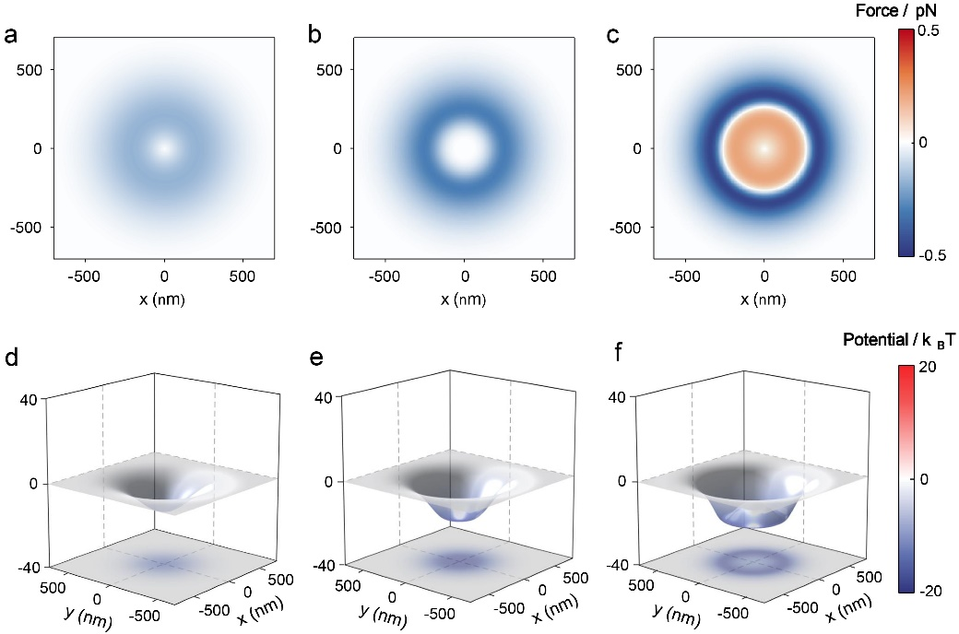

**Fig. S4. Optical force and trapping potential distributions within the SA regime.** (a-c) Radial optical force and (d-f) trapping potential distributions in the focal plane acting on the gold nanoparticle, when the averaged incident power *P*ave = 0.11 W, 0.17 W, and 0.3 W. These powers correspond to the points A, B, and C labelled in Fig. 2(c), respectively.

For the pulsed laser at a relatively low power, the nonlinear response strengthens the optical forces at the beginning. The gradient force becomes stronger gradually and generates a deeper trapping potential well with an increased incident power, until the extinction cross-section *σ*ext reaches a peak value at 0.17 W which is marked as the point B in the SA process. At this point, the magnitude of the gradient force is close to zero in a certain region, as shown in Fig. S4(b). The corresponding potential well becomes flat in a certain region and the depth of the potential well is −14 kBT, as shown in Fig. S4(e). When the incident power is further increased, e.g., at the point C with average power *P*ave = 0.3 W, the reversed optical force (red color) emerges in the center region, whose direction points away from the center point, as shown in Fig. S4(c). In such condition, the maximum of this opposing force is 0.45 pN and the depth of the potential well is −19 kBT, as can be seen in Fig. S4(f). At this point, the surface shape of the potential well changes to a convex plane in the region within reversed gradient force. Consequently, an annular trapping potential well is formed to actuate the nanoparticles to experience an orbital circumgyration.

**Supplementary Note VI: The change process of force in RSA regime**

At the incident average power of 0.7 W (D point in Fig. 2), the direction of forces at the center region points backwards the center point, as shown in Fig. S5b. When average power 𝑃ave is 1.10 W, the force at the focal center becomes smaller but its direction remains unchanged, as shown in Fig. S5c. At the peak point of the extinction cross-section in the RSA process (E point), the average power 𝑃ave is 1.15 W. For this circumstance, the curve of the force near the focal center point becomes flat, and the magnitude of the gradient forces is several orders smaller than the others, as can be seen in Fig. S5d. As the average power is increased to 1.20 W, the direction of the gradient force at the focal point starts to reverse, as illustrated in Fig. S5e. For 𝑃ave = 1.50 W, the force at the focal region exceeds the outer part.

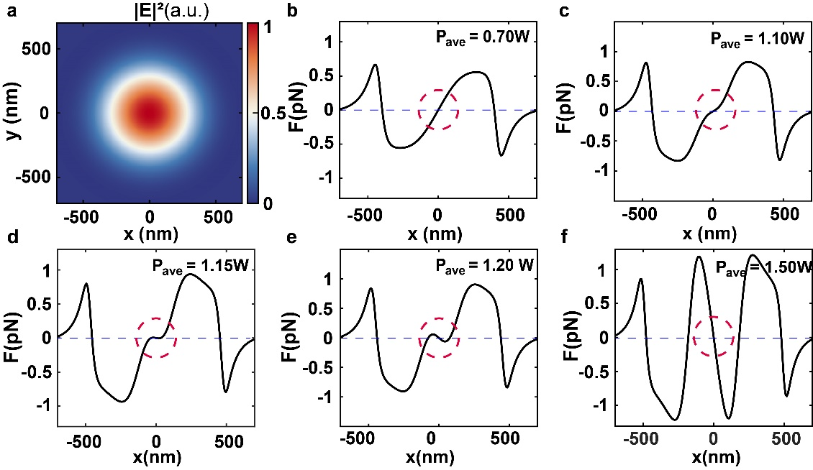

**Fig. S5**. **The optical force and potential well in the RSA process**. (a)Normalized intensity distribution of the electric field in the focal plane. (b)-(f) Optical forces along the x-axis in the focal plane with average incident power of 0.7 W, 1.10 W, 1.15 W, 1.20 W, and 1.50 W, respectively.

**Supplementary Note VII: The rotation speed of the trapped particle**

In our work, many experiment conditions stay the same with Ref. [10], for example, NA of the objective lens, size of nanoparticles, central wavelength, and the repetition frequency of the trapping laser. The only different parameter is the pulse duration, which results in different input peak power. According to the measurements provided in Ref. [10], there is a strong correlation between the rotation speed and the input peak power. Therefore, by carefully comparing the peak power of the incident pulse in our work with that in the reported experiment, we can draw a reasonable conclusion for the rotation rate, as shown in Table S2.

According to the results in Fig. R2 of Ref. 10, the rotation speed is nearly a linear function with the incident laser. Thus, we can approximately estimate the rotation speed with average power of 0.7 W, 1.15 W, and 1.54 W, which refer to the points D to F in our work, respectively. The estimated rotation speeds are shown in the right half part of Table 1.

**Table S2. Rotation speeds of the gold nanoparticle under different input powers**

|  |  |  |  |  |  |  |
| --- | --- | --- | --- | --- | --- | --- |
|  | Ref. [10] | | | This work | | |
| Point D | Point E | Point F |
| Pave/ W | 0.35 | 0.5 | 0.65 | 0.7 | 1.15 | 1.54 |
| Ppeak /W | 6.25 | 8.93 | 11.6 | 8.76 | 14.38 | 18.76 |
| Rotation speed | 220 r/s | 235 r/s | 250 r/s | 230 r/s* | 260 r/s* | 290 r/s* |

Note: * Estimated rotation speed of GNP in our work.

**Supplementary Note VIII: The heat process under illumination of femtosecond pulses**

The illumination using a femtosecond pulsed laser can confine the heat within the close vicinity of the nanoparticle, preventing extended heating of the surrounding environment52. Compare to the absorption coefficient of the gold NP (a_Au= 8.2053 cm-1) 53, the absorption coefficient of water (a_Water= 1.9639 cm-1)54 is extremely small at the wavelength of 800 nm. The temperature increase is mainly caused by gold nanoparticle absorption. The absorption of laser pulse energy by a gold nanoparticle can be described as a three-step process20,55, each of these steps involving different time scales as follows:

1. *electronic absorption:* During the SA and RSA process, part of incident laser pulse is absorbed by free electrons of the gold NP. The electronic gas thermalizes over a time scale τe-e ~ 220 fs20. The temperature of electron (*T*e) is increased but the temperature of phonon (*T*ph) remains unchanged.
2. *Electron-phonon thermalization:* The hot electronic gas relaxes thorough an electron-phonon interaction (τe-ph ~ 1.7 ps)55. The ion of the gold lattice is heated due to the electron–phonon interaction and this step is independent on the size of nanoparticle. At this step, the nanoparticle is in internal equilibrium at a uniform temperature (*T*e= *T*ph) but is not equilibrium with the initial ambient temperature.
3. *External heat diffusion:* The energy diffusion from the nanoparticle to the surrounding environment (water) usually occurred at longer time scale and lead to a cooling of nanoparticle and the heating of the surroundings. The time scale of this step depends on the size of the NP and ranges from 100 ps to a few nanoseconds56.

In the ideal case, the heat source (the gold nanosphere) can be modeled as a dipole, the heat power density can be described by a Dirac distribution57



where ρw is the mass density of water, *cw* is the specific heat capacity at constant pressure, and *kw* is thermal conductivity of the system at the time *t* and distance *d* from the dipole, σ*abs* is the absorption cross section of the nanoparticle, *Iave* is time average optical intensity, and *f* is the repetition rate of the pulse. The ideal problem has an analytical solution with the thermal diffusivity of water aw which can be written as58



Considering a realistic spherical nanoparticle (r = 30 nm), there is no analytical solution but the approximation can be done according to the above equation. The initial temperature can be obtained by calculating the time *t* for $∂_{t}T(d,t)=0$ at the original point (*d* ≈ 0). Then the temperature increase of gold nanoparticle reaches its maximum value at its center point which can be described as57



where ρ*Au* is the mass density of gold, *cAu* is the specific heat capacity of gold at constant pressure, and *V*is the volume of the nanosphere.The time evolution of the temperature in the nanoparticle can be conveniently fitted using a stretched exponential function57



We then use this function to fit the evolution of the temperature, as plotted in Fig. S6. The optimized fit parameters are *n* = 0.39 and τ0 = 0.041. Note that the pulse repetition *f* = 80MHz and pulse duration is 100fs. The average power is 1.5W. These parameters correspond to those configured at point F. The sampling time is 50 ns. The room temperature is 23 °C. Fig. S6 illustrates the temperature gain and loss as a function of time under the pulsed illumination. The temperature of the nanoparticle rises instantaneously to the maximum value and then drops back to the room temperature after a few hundred picoseconds.

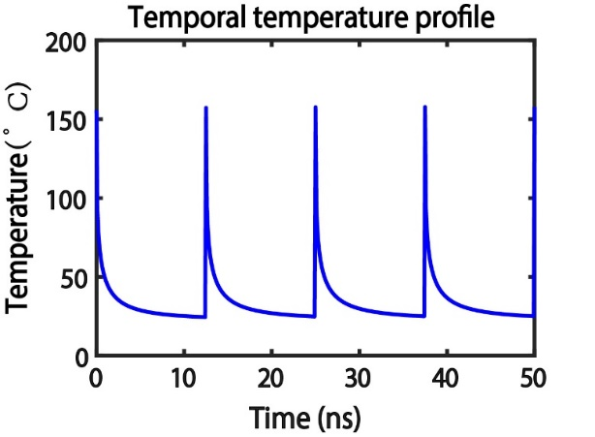

**Fig. S6**. The temporal temperature profile at the original point of the GNP. The repetition rate of pulse is 80 MHz. The time scale is 50 ns.

We then discuss the subsequent spatial evolution of the temperature in surrounding environment. Firstly, the initial temperature *T* (*d*,0) remains uniform inside the sphere (0 < r ≤ 30 nm) because the thermal conductivity of the gold *kAu* is much higher than *kw*. Then it generates a temperature envelope57,

Initial temperature：



Boundary conditions:



Diffusion equation:



The Eq. (S17) is the boundary condition at the interface from the energy conservation law. Similarly, when considering a finite size nanoparticle, a stretched exponential function can also be used to fit the envelope of the spatial temperature profile in the surrounding water58:



The fit parameters are n = 0.45 and ρ0 = 0.06. 58 The result is presented in Fig. S7 with the spatial temperature of the nanoparticle. For a large interface resistivity59,60, the heating of the surrounding fluid can be highly inefficient. The spatial temperature profile reveals that the temperature outside of the nanoparticle rapidly returns to the room temperature over a short distance. Therefore, the temperature rising is completely ignorable in this work.

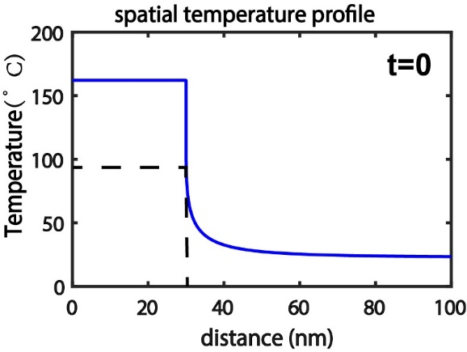

**Fig. S7**. The temperature envelope of the spatial evolution for the system consisting of a particle (r = 30 nm) in water.